# **De-Stress Zone**

### It's a scary world. Here are some ideas for surviving it.

Zoe's avatar

[Zoe](https://substack.com/@zoeffc)

Apr 18, 2025

4

[2](https://femmefuturescooperative.substack.com/p/de-stress-zone/comments)

1

Share

Hi y’all,

It is Thursday, April 17th, as I write this. Today is my partner’s birthday. Instead of clocking into work this morning, I sat down for a birthday breakfast with him and his family. For his birthday, all he wanted was to be in the woods, swim, and maybe climb. How better to spend your day than to do things that fill your cup?

One of my ultimate burnout tips is to pay attention to what “fills your cup”. This metaphor is specifically resonant to me because it doesn’t necessarily need to be “fun” or anything high energy. Some days at work, spending a couple of hours working on an Excel sheet fills my cup. The thing is that some days, that exact task drains that cup. It’s finicky. Oftentimes, being around my team will fill my cup, but sometimes it fills it less than other times.

Is that making any sense?

Long story short — this is my call for you to pay attention to what feels energizing to do and to try to work as much of that into your days, especially when they feel low and slow.

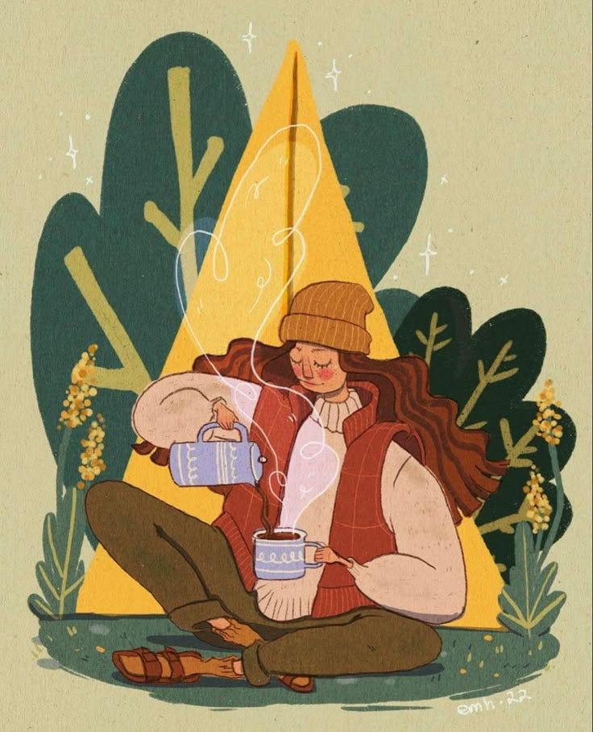

Before I go any further — let’s do the housekeeping.

First, if you are not already a subscriber and you resonate with any of the following descriptors, consider joining the cooperative: (1)Early-career professional; (2) Feminist; (3) Do-gooder; (4) Former Gifted Kid; (5) Overachiever; or (6) Capitalism-hater.

Subscribed

Second, if you like what I am saying and it makes you think of someone in your family/office/friend group, send it their way.

[Share Femme Futures Cooperative](https://femmefuturescooperative.substack.com/?utm_source=substack&utm_medium=email&utm_content=share&action=share)

Third, I say some personal and vulnerable shit every week. Say some vulnerable shit back. It’s called a community.

[Leave a comment](https://femmefuturescooperative.substack.com/p/de-stress-zone/comments)

Okay — back to it.

**Here are some ideas on how to fill your cup (at work):**

1. Tell someone a funny story from your life. (Connection and vulnerability not only fill your cup in the short term, but can also passively fill your cup in the long term.)
2. Stop what you are doing and doodle a carrot on a Post-it. (Here - I’ll even give you an example carrot doodle.)
3. Spend some time on a professional development goal. Read an article. Take a course. (It’s a brain break AND it reminds your mind that you are not stagnant, but are in fact growing and learning constantly.)

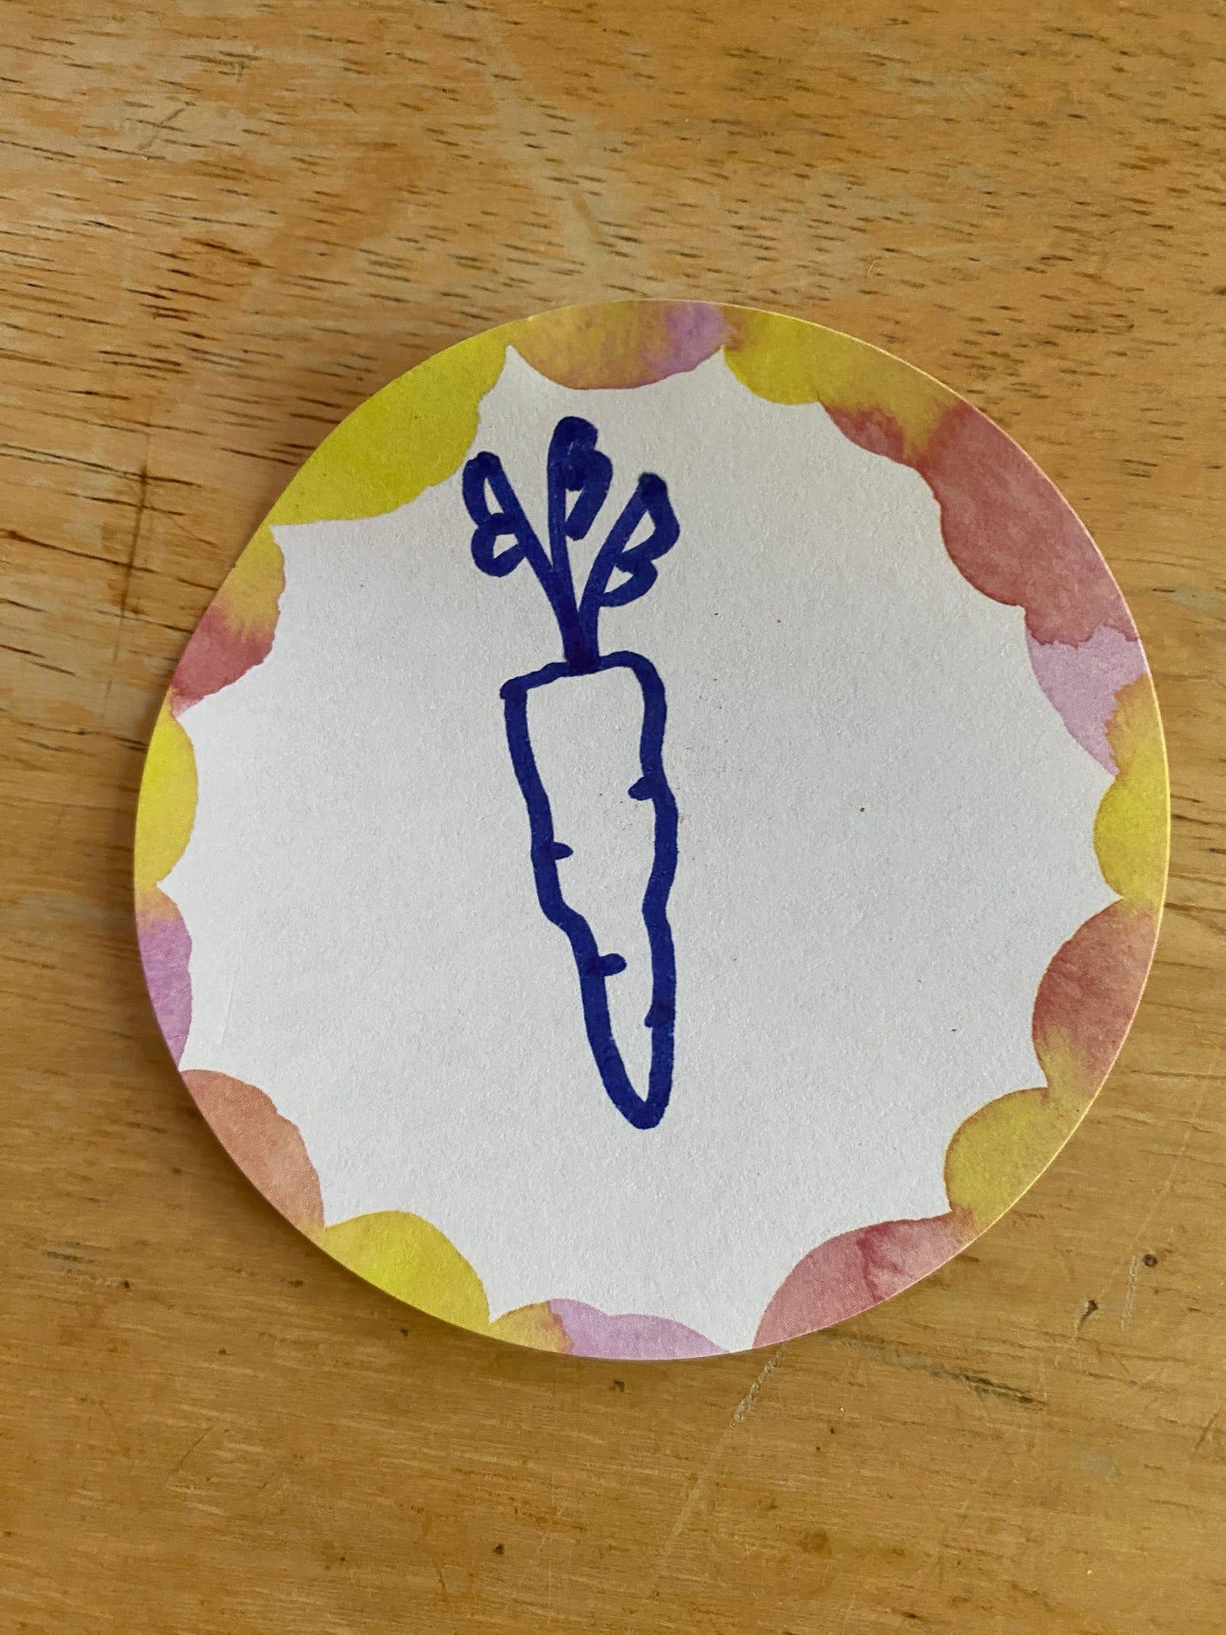

My Post-it Carrot. I am still working on my carrot top technique.



Get more from Zoe in the Substack app

Available for iOS and Android

[Get the app](https://substack.com/app/app-store-redirect?utm_campaign=app-marketing&utm_content=author-post-insert&utm_source=femmefuturescooperative)

**Here are some ideas on how to fill your cup (not at work):**

1. I would highly recommend standing in direct sunshine. If you have the time, spend so many hours in direct sunlight that you get that sunshine-sleepy feeling.
2. Take a long lunch break to make some interesting food. Or spend your work day thinking about what you COULD cook when you get home. Drive to the grocery store and pick up ingredients on your way home. Cook yourself a semi-complex meal.
3. [Read the Femme Futures archive.](https://femmefuturescooperative.substack.com/?sort=top)

I hope you have a great day.

Best,

Zoe